ONLINE BANKING
Getting Started:
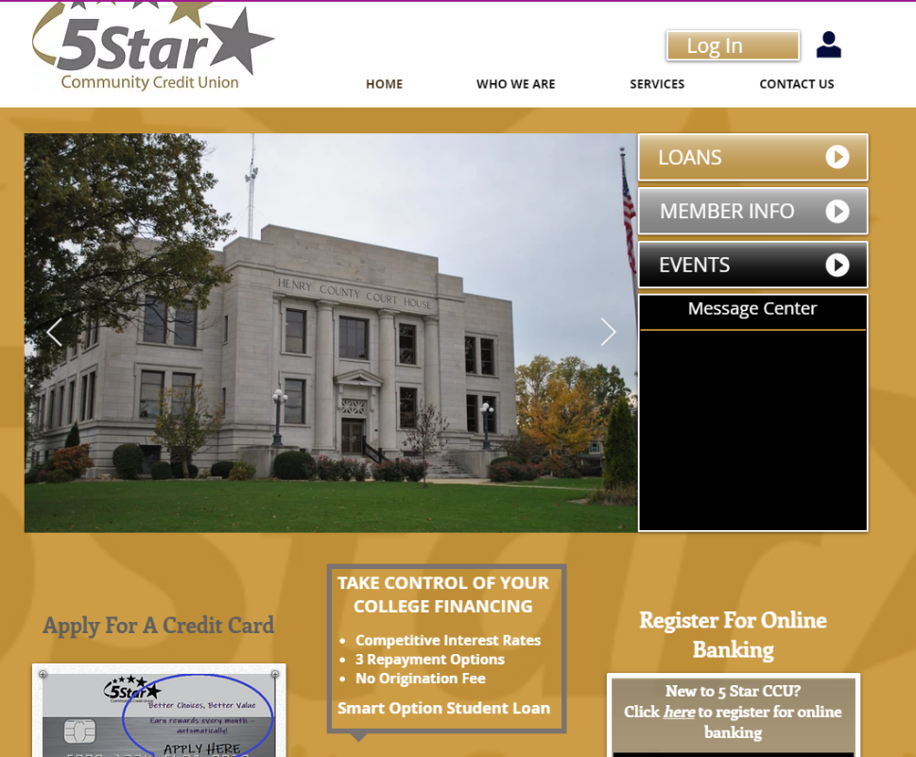
Go to home page at www.5starcu.org Click on the Online banking icon to register.

Login Page
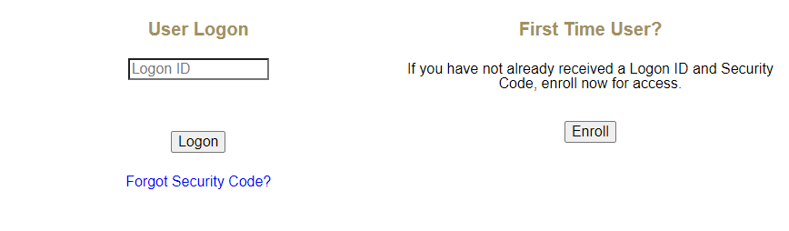

If this is your first time registering, click on Enroll under “First Time User?”

Enrollment page
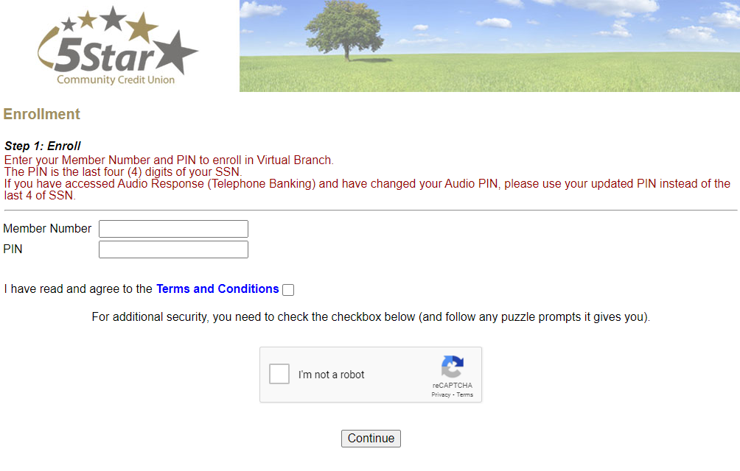
Your Member Number will be your account number.
Please note, Account number only, no leading zeros and no trailer numbers (ex: 999999).
Pin number is the last 4 of your social UNLESS you have changed your Audio Pin through our 1-800 number. Your debit card PIN will not affect either of these

Fill in all the information and hit enroll

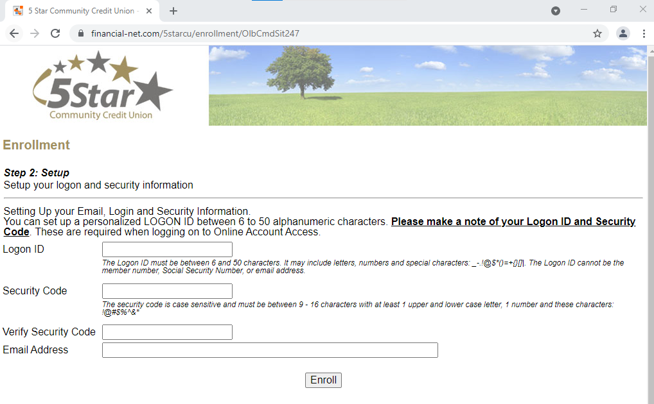
Confirmation page

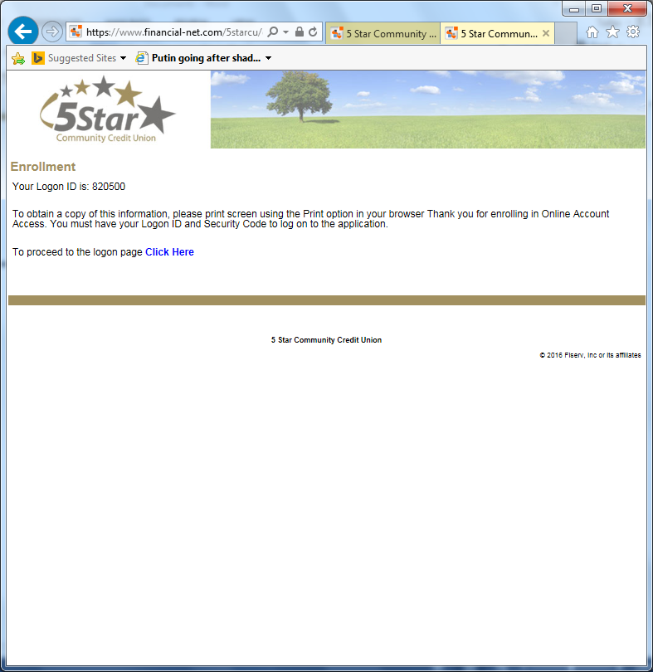

Answer security questions

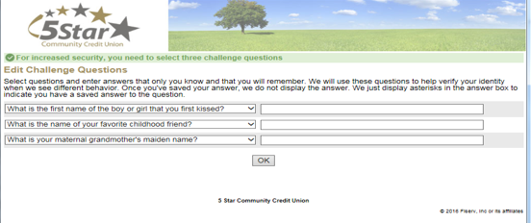

Enter a security Phrase (Ex. Sunshine, Flower)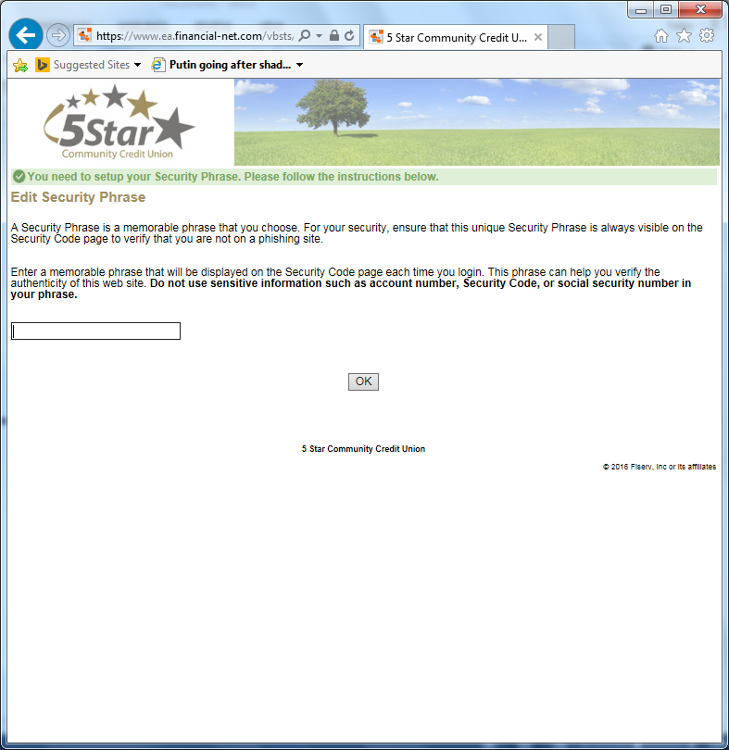

Check Settings
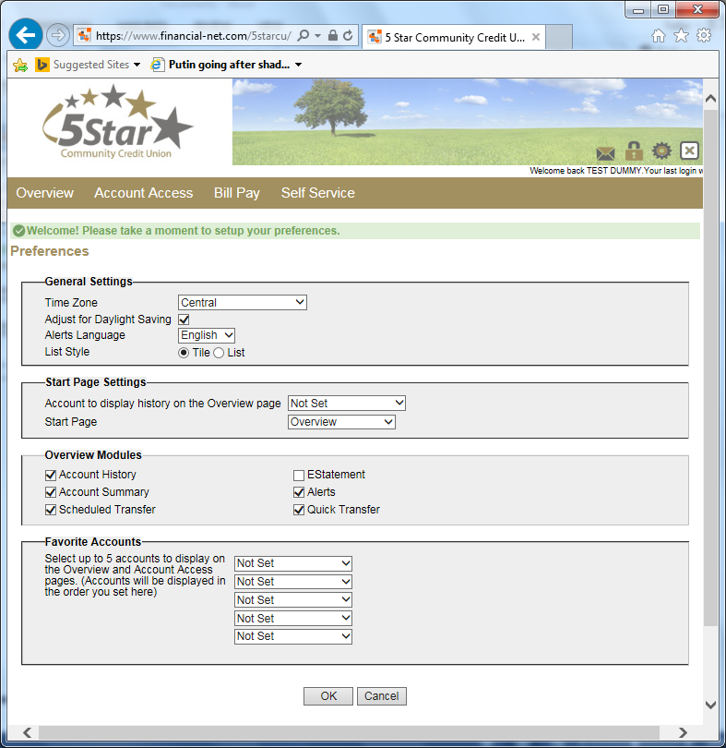

You have now completed your registration for your online banking.
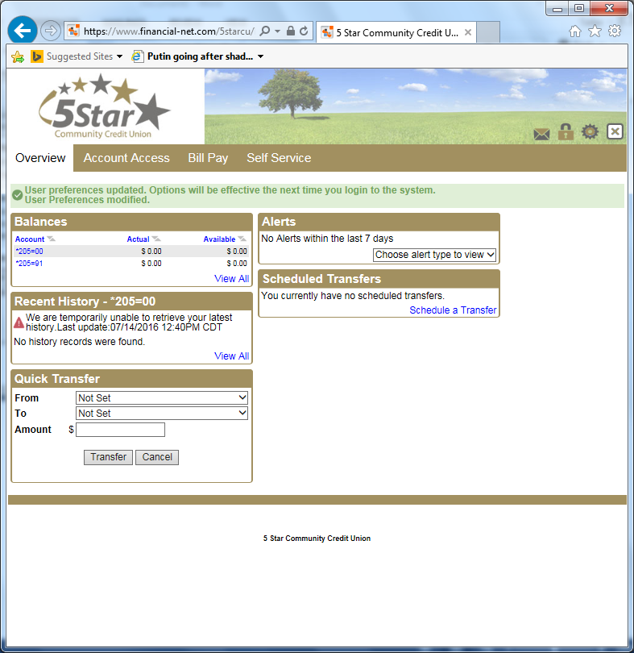
REMEMBER TO WRITE DOWN YOUR LOGIN INFORMATION AND SECURITY QUESTIONS FOR FUTURE PURPOSES.

ENJOY YOUR ONLINE BANKING. PLEASE CALL US AT 319-385-4914 WITH ANY QUESTIONS YOU MAY HAVE.

